MIDTERM PART B
SPRING 2026
SOLUTION

Q 1 (a) A consistent system of equations is a system that has at least one solution.
That solution may be unique or there may be infinitely many solutions.
If a system has no solution, it is called inconsistent.

(b) Write the augmented matrix:
$$\left[\begin{matrix}4 & -6 & ∣ & b_{1} \\ 2 & -3 & ∣ & b_{2}\end{matrix}\right]$$
Step 1: Swap rows
$$R_{1}↔R_{2}⟹\left[\begin{matrix}2 & -3 & ∣ & b_{2} \\ 4 & -6 & ∣ & b_{1}\end{matrix}\right]$$
Step 2: Eliminate the second row
$$R_{2}←R_{2}-2R_{1} \\ \left[\begin{matrix}2 & -3 & ∣ & b_{2} \\ 0 & 0 & ∣ & b_{1}-2b_{2}\end{matrix}\right]$$
Consistency Condition
For the system to be consistent, the second row must not represent a contradiction.
Thus, the augmented entry must be zero:
$$b_{1}-2b_{2}=0 \\ \boxed{b_{1}=2b_{2}}$$
$$\boxed{\text{The system is consistent if and only if }b_{1}=2b_{2}.}$$

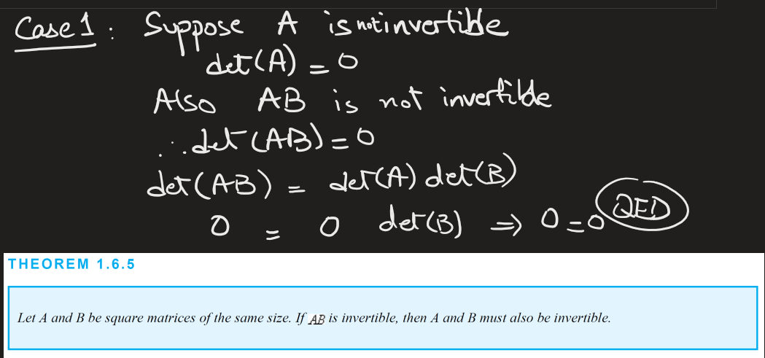
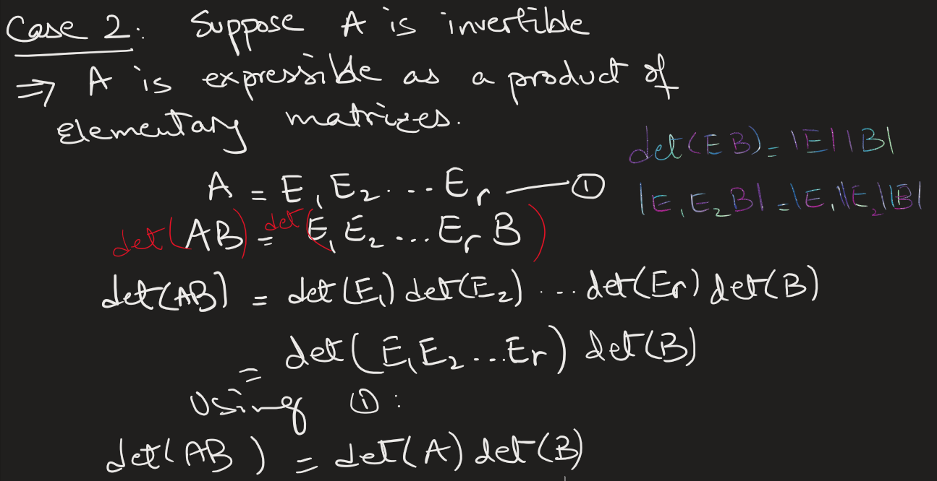
Q 2.

Q 3 (a)
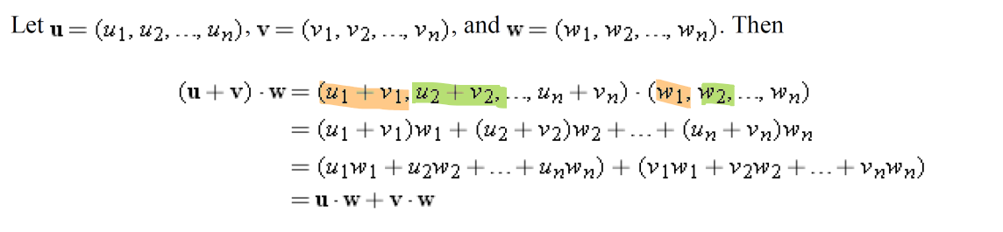

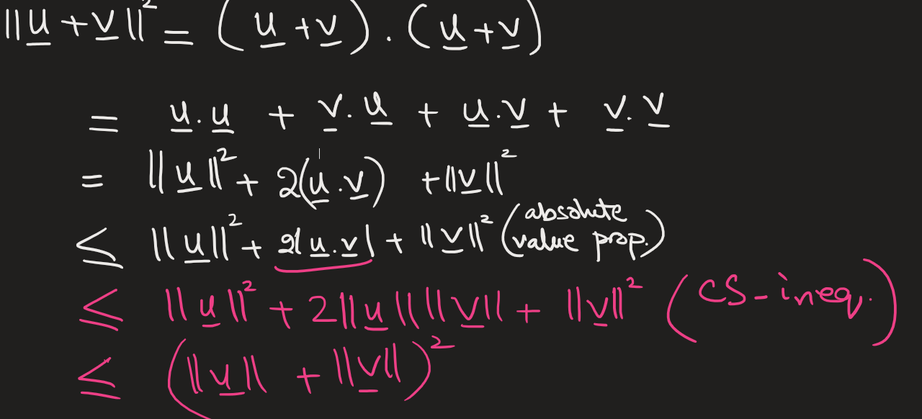
(b)

Q 4 (a) A matrix is in reduced row echelon form (RREF) if all of the following conditions are satisfied:
- All nonzero rows are above any rows of all zeros.
(Any rows that are entirely zero must be at the bottom.)
- The first nonzero entry in each nonzero row is 1.
This entry is called a leading 1 (or pivot).
- Each leading 1 is to the right of the leading 1 in the row above it.
(Pivots move strictly to the right as you go down the rows.)
- Each leading 1 is the only nonzero entry in its column.
(All other entries in the pivot’s column are zero, both above and below.)
(b)
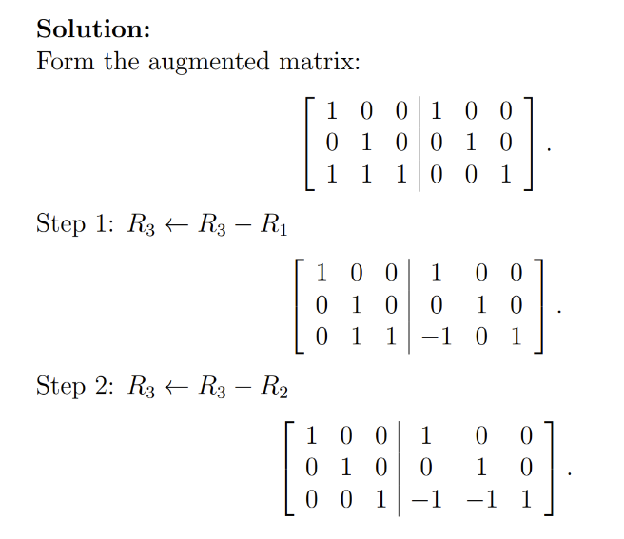

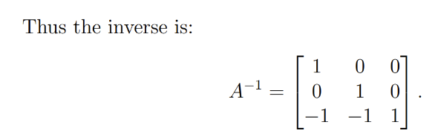

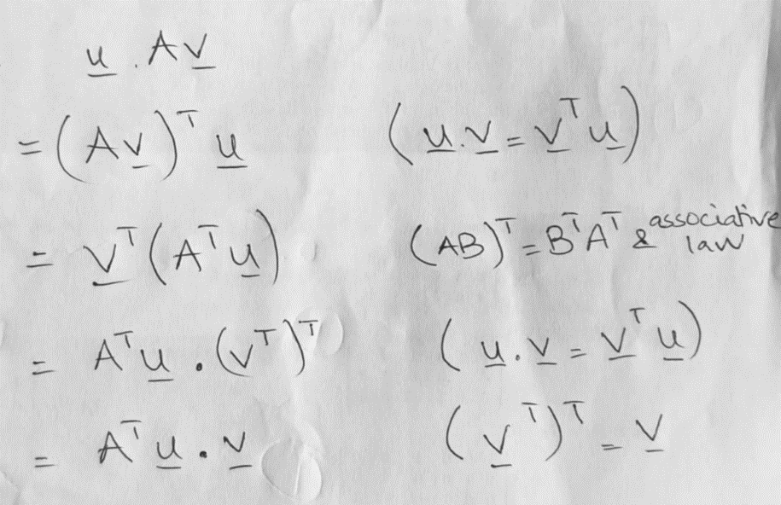
Q. 5

